Department of Electronic and Telecommunication Engineering

University of Moratuwa



**Hearing Aid**

Group 12

H.U.D.B. Haputhanthri 170208K

D.B. Ishtaweera 170242H

S.N. Liyanagoonawardena 170348M

R.M.S.N. Rajapakshe 170476D

This is submitted as a partial fulfillment for the module EN 2110 – Electronics III

14th February 2020

**Abstract**

**The aim of this project is to produce a high quality hearing aid utilizing a suitable power amplifier under a low cost. This device is extremely useful for the users who are suffering from partial or full hearing impairment. Currently the prices of hearing aids range from $1000 to $4000 depending upon the level of technology. In this project we utilize a mic, a pre-amplifier, a power-amplifier of Class AB, a power supply unit and a headphone sequentially. As we successfully obtained the expected results and considering its efficiency, low cost and simplicity this project can be expected of a vast market demand with a bit more improvement and a professional touch.**

**Contents**

1. Introduction
   1. Overview
   2. Objective
   3. Algorithm
2. Method
   1. Description
   2. Schematics
   3. Simulation
   4. PCB design
   5. 3D design
   6. Enclosure
3. Results
4. Discussion
5. Conclusion
6. Acknowledgement
7. **Introduction**
   1. **Overview**

By the year 2018, 18.5% people among the world population is suffering from hearing loss. This occurs as a result of damage to the sensory hearing cells within the ear. According to the National Institute on Deafness and other Communication Disorders “approximately one in three people between the ages 65 and 74 has hearing loss and nearly half of those older than 75 have difficulty hearing.” As per children approximately 2-3 of every 1000 children are born with a detectable hearing loss and they are severely affected with their ability to learn and advance in school due to their difficulty in hearing.

At present prices of hearing aids in the market vary from $1000 to $4000 and according to a survey conducted by the Better Hearing Institute hearing loss negatively impacts household income on average up to $12,000 per year.

* 1. **Objective**

The objective of this project is to provide an efficient, practical and sufficient solution to the disability of hearing high frequencies which is affordable to the Sri Lankan market. This will be implemented using a pre-amplifier, Class AB power amplifier, a power supply unit, a mic and a headphone where the power amplifying process takes the foremost interest

* 1. **Algorithm**

Input

Sending the signal through a power amplifier to obtain a current gain.

Sending the signal through a pre-amplifier to obtain a voltage gain

Output

1. **Method**
   1. **Description**

The project consists of four main stages;

* + 1. Input stage via a microphone
    2. Pre-amplifier
    3. Power-amplifier
    4. Output stage via headphones

The input audio signal to the system is captured via a microphone which is given a 5V supply and the output from the microphone is directed towards the pre-amplifier through a capacitor.

The pre-amplifier stage utilizes a LM324 op-amp which conducts the voltage amplifying of the captured audio signal efficiently. The reason behind employing a premade op-amp over custom made pre-amplifying circuit is that it provides a much higher amplification to noise ratio which is unreachable in the latter. Also LM324 provides a higher area efficiency which crucial in a hearing aid in practice. The pre-amplifier is provided with a 5V voltage supply while the non-inverting input is given a 2.5V input through a voltage divider, to avoid the clipping of the negative part of the signal. This is because if given 0V the pre-amplifier fails to output the negative half cycles of the signal.

The output from the pre-amplifier is given to the power amplifier circuit. The utilized power-amplifier class in this project is class AB which provides a much higher amplification (than class A) while avoiding the cross-over distortion (present in class B) completely. This is implemented through the use of complementary transistor pairs npn(BC639) and pnp (BC640). Additionally, we have used and adjusted the variable resistors with suitable values to correctly bias the power amplifying circuit. Furthermore, it should be highlighted that we have utilized a Vbe multiplier instead of diodes in the conventional class AB power amplifier to avoid unpredictable voltage drops (other than 0.7V) that are possible in practice.

The output from the power amplifier is then sent on through a capacitor which is then sent out from the system through a headphone.

* 1. **Schematics**

The following figure shows the schematic design of the circuit utilized. It includes;

1. a power supply circuit
2. an audio signal input circuit
3. a pre-amplifier circuit
4. a power amplifier circuit

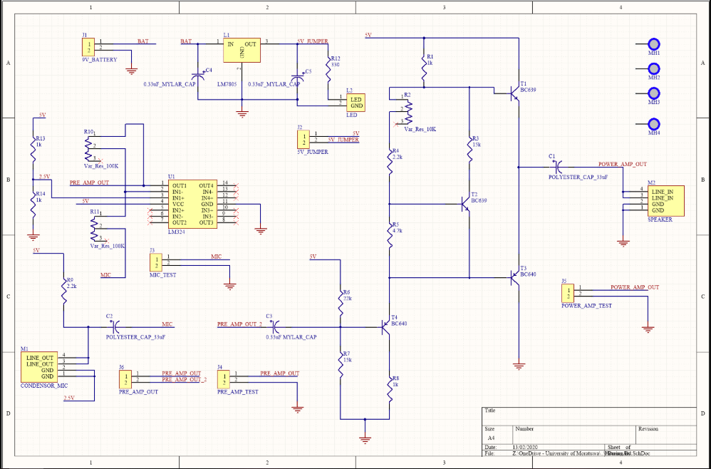

Fig 2.1 The schematic of the circuit

* 1. **Simulation**

The following figures show the simulation results of the circuit using LTspice XVII.

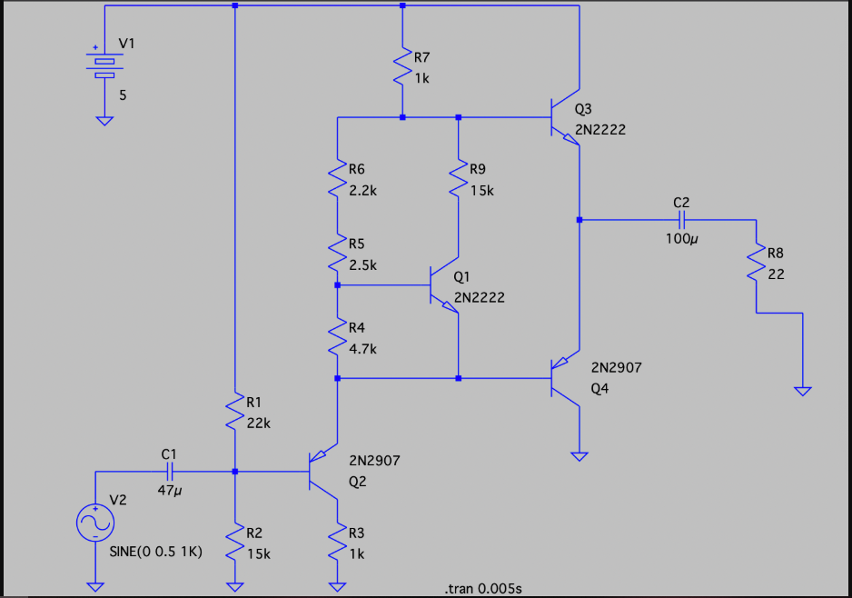

Fig 2.2 The LTspice circuit

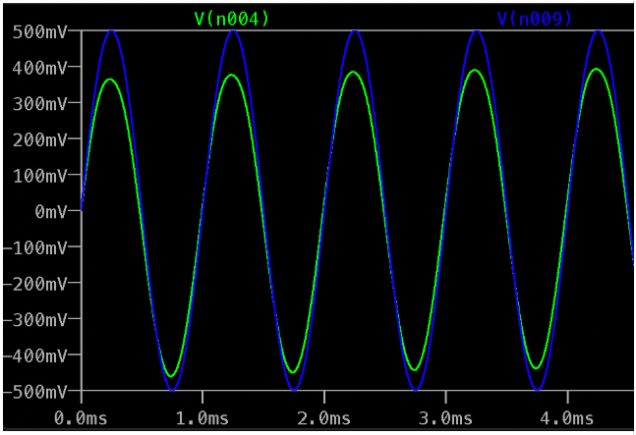

Fig 2.3 The simulation diagram of the input-output voltages of the power-amplifier

Diagram in green depicts the output voltage from the power amplifier and the diagram in blue depicts the input voltage to the power amplifier.

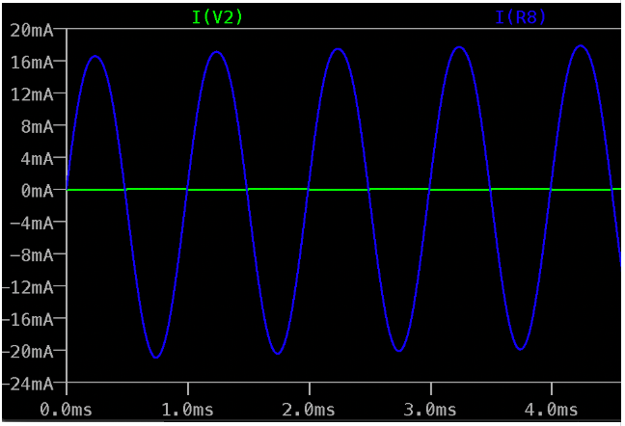

Fig 2.4 The simulation diagram of the input-output currents of the power-amplifier

Diagram in blue depicts the output current from the power amplifier and the diagram in green depicts the input current to the power amplifier.

* 1. **PCB design**

The following figures show the PCB design of the project using Altium Designer 17.

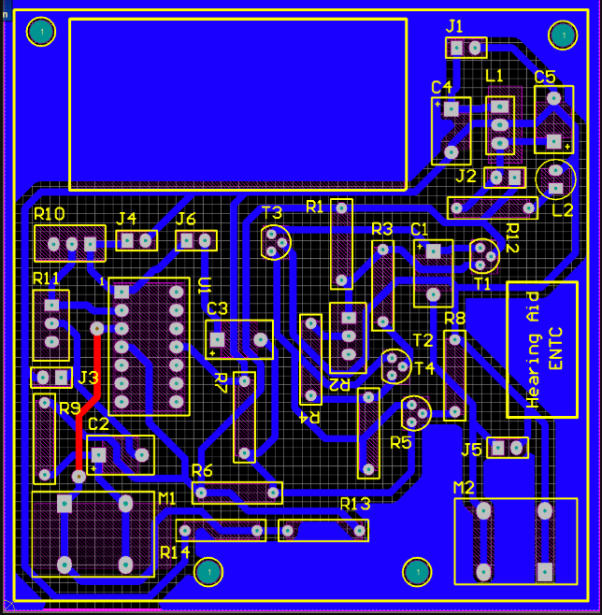

Fig 2.5 The PCB layout of the circuit

* 1. **3D design**

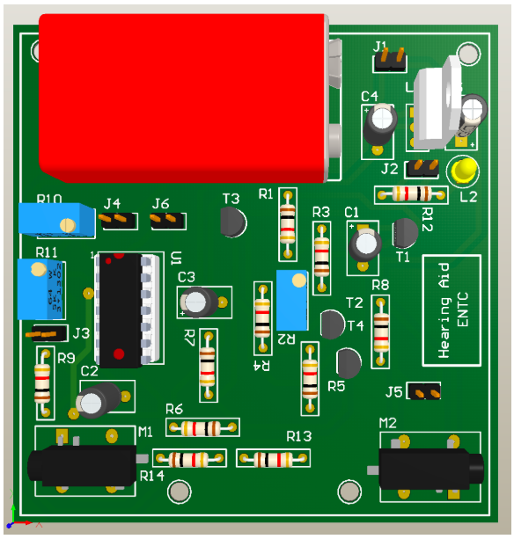

Fig 2.6 The 3D design of the circuit

* 1. **Enclosure**

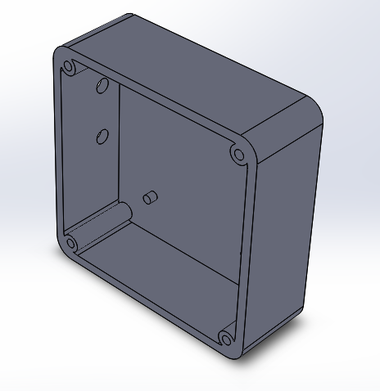

Fig 2.7 The bottom of the enclosure design

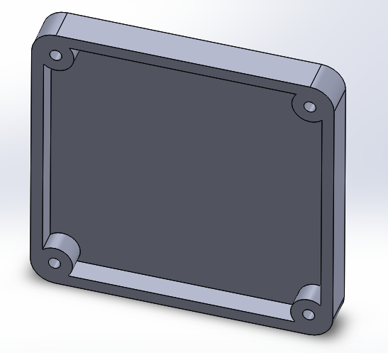

Fig 2.8 The top of the enclosure design

1. **Results**

The following table shows the percentage of ideality of the output signal of the hearing aid w.r.t. to;

1. noise present

2. amplification of the signal

on the three trials.

|  |  |  |  |  |
| --- | --- | --- | --- | --- |
| TRIAL | TRIAL 1 | TRIAL 2 | TRIAL 3 | Final |
| OVERALL SUCCESS | 0% | 30% | 70% | 100% |
| AMPLIFICATION | 0% | 50% | 80% | 100% |
| NOISE PRESENT | 0% | 80% | 10% | ~0% |

1. **Discussion**

The foremost issue faced in implementing this project was that the circuit implemented in the PCB was not producing an output even though the exact same circuit implemented in the breadboard was producing a clear and amplified output signal to a given input. After much observation it was realized that the transistors used in the power amplifier had less voltage drop across the Base and the Emitter than 0.7V. This had resulted in a lower than expected voltage drop across the push pull configuration of the class AB circuit and had failed in biasing the transistors properly. This issue was overcome by short circuiting the 2.2k resistor utilized in the Vbe multiplier in the power amplifier and adjusting the variable resistor to a low value.

Another issue faced in implementing the pre-amplifier was that the output obtained by the pre-amplifier circuit produced a clipped output signal that didn’t output the negative half cycles of the signal. This is due to the single rail power supply utilized in the circuit and hence the negative voltages are clipped. To solve this issue, we shifted the signal to a reference of 2.5V, using a voltage divider circuit and giving a 2.5V to the non-inverting end of the op-amp and successfully obtained the negative half cycles of the amplified signal with a voltage gain.

Additionally, we utilized a LM324 op-amp for the pre-amplifying circuit instead of a custom designed pre-amplifier, as LM324 provides a higher voltage amplification and much less noise than an analog pre-amplifying circuit is capable and allowed a much higher area efficiency which is crucial in a practical hearing aid. Also, the use of the op-amp lead to a change in the supply voltage to a single rail 5V power supply, as before we planned and designed the circuits for a single rail 3V power supply.

Furthermore, we used transistors instead of diodes used in the conventional class AB power amplifier as the voltage drop across the diodes can slightly vary in practice and can negatively affect the biasing of the circuit.

1. **Conclusion**

After analyzing the final results obtained it is clear that the device has been successfully implemented and that with a bit of professional touch and further reduction of area paves way to a low cost, high quality hearing aid solution in the Sri Lankan market.

Furthermore, it can be deducted that the main goals of this project were successfully achieved such as; having a deeper understanding of the practical usage of each class of power amplifiers and choosing the most suitable class through comparison, correct implementation of the class AB power amplifier with correct biasing and complementary pairs, correct implementation of the pre-amplifier with most efficiency w.r.t. signal amplification and noise and also facing the issues that arises when practically implementing a hearing aid and successfully identifying and overcoming them. Hence, this is a very fruitful project that accomplished all its intended purposes.

1. **Acknowledgement**

A special thanks goes to our lecturer, Mr. Thilina for not only providing us with all the necessary theoretical knowledge regarding power amplifiers but also for constantly guiding us in this project and advising us when we practically encountered major technical issues. We would also like to express our gratitude to the staff of ENTC laboratories without whom we could not accomplish the project.